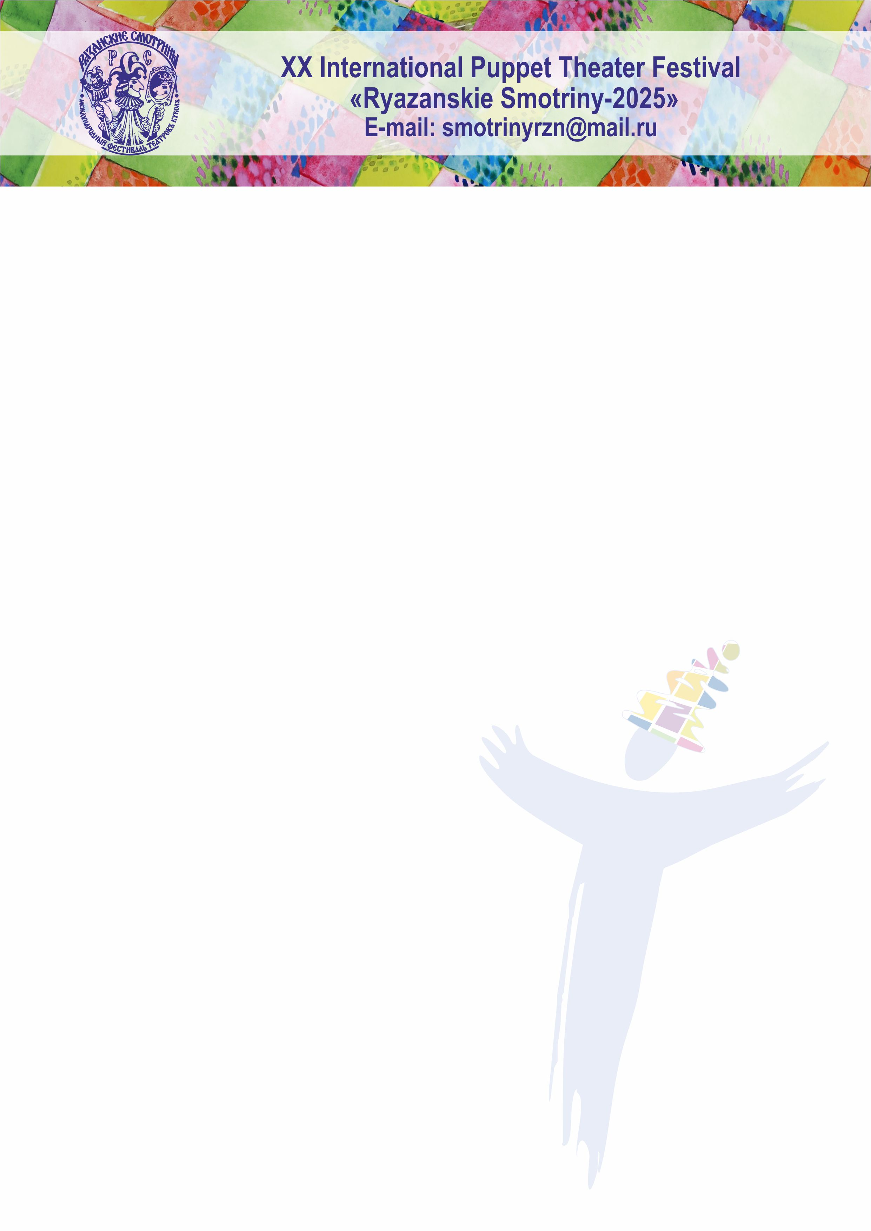

INTERNATIONAL PUPPET THEATER FESTIVAL
“RYAZANSKIE SMOTRINY-2025. WAY TO THE EAST”

REGULATIONS

  - AIMS AND OJECTIVES
1.2. Preservation and development of a common cultural space and traditions of the art of puppet theater, straightening of inter-ethnic, inter-regional and inter-state cultural relations and historically established ties and traditions of the puppeteers in Russia and abroad.
1.3. Introduction of the Ryazan audience to the variety of forms and types of puppet theater art in Russia and abroad and to the shows realized within the last two years.

- FOUNDER OF THE FESTIVAL
State Autonomous Culture Organization “Ryazan Puppet Theater” with the assistance of the government of the Ryazan region, ministry of culture of the Ryazan region, theater Workers’ Union of the Russian Federation, the Ryazan region theater Workers’ Union of the Russian Federation, UNIMA Russia.

3. GENERAL REGULATIONS
3.1. Venue: Ryazan city, State Autonomous Culture Organization “Ryazan Puppet Theater”, stages of the city.
3.2. Frequency – every two years.
3.3. Festival duration and dates in 2025: seven days, from 12th September till 18th September, 2025.
3.4. The preparation and holding of the Festival is realized by the Organizing Committee and Directorate.

4. ORGANIZING COMMITTEE

4.1. In the Organizing committee there can be representatives of Ryazan Government, representatives of the Culture Ministry of Ryazan region, workers of Ryazan Puppet Theater and invited experts.
4.2. The organizing committee defines the time and place for holding the Festival, app the program of the Festival.

- DIRECTORATE OF THE FESTIVAL
5.1. The directorate makes all the current work in organizing and holding of the Festival

6. FEATURES OF THE FESTIVAL
6.1. The Festival “Ryazanskie Smotriny” is non-competitive. All participants receive the diplomas of the participants and original memorable presents.
6.2. At the closing ceremony, each participant of the Festival can establish and present his own prize in his own nomination. For instance, “The Best Artist”, “The Best Choreographer”, “The Best Light Designer”, “The Best Curtain Opener”, etc.
6.3. The Festival is attended by representatives of the Russian theater schools, World’s leading figures in art of the Puppet Theater, theater experts and critics.
6.4. Each company has the right to an individual discussion of the presented show with these specialists.
6.5. In 2025, for the first time at the Festival there will be organized a specially prepared business program “IT’S ALL IN THE THEATER” for the managers and leaders of the theater companies.
6.6. In 2025, at the Festival there will be held a unique project – the International school-laboratory “WE ALL LIVE UNDER THE SAME MOON” for the fourth time.
7. FINANCIAL RESOURCES OF THE FESTIVAL
7.1. The budget is formed by funding of various levels of specialized executive authorities, and by extra-budgetary sources.
7.2. On decision of the Board of Directors, the financial resources can be spent only for the preparation and holding of the festival according to the approved estimates.
Tickets sales income of the Festival shows remains at the disposal of Ryazan Puppet Theater.
7.3. The Directorate provides meals, accommodation, transfer “Moscow-Ryazan-Moscow” (if it is necessary), intercity transportation for the entire period of the festival (if it is necessary).
7.4. At the Festival fees for the shows aren’t paid to the companies or their representatives. In exceptional cases, the directorate of the Festival can make a decision to pay the fee in a special order.

8. CONDITIONS AND PROGRAM
8.1. Theaters of any form and any kind of theater property can be a participant of the Festival.
8.2. The festival accepts the most vivid and modern in artistic terms performances, these shows should be premiered no later than two years before the start of the current Festival.
8.3. The delegation of the participating company should not exceed 10 people (together with the management). In case of exceeding this number, the contributing party covers the costs of the additional number of participants in the delegation.
8.4. The company gives the application (in the attached form) to the Organizing Committee until 1st February 2025. The Expert council makes analysis and selection of the applications. In case, the show becomes a participant of the Festival, the company needs to fill in an application-form.
8.5. Based on the application and recommendations of the experts, the Organizing Committee decides to invite or not to invite the company and informs the participants about its decision in the period from 1st April to 1st May, 2025.
8.6. The Festival is widely covered in the local and central media.
8.7. Information about the Festival is published on the Ryazan Puppet Theater website and in its official groups on the social network.
ADDRESS OF THE ORGANIZING COMMITTEE AND DIRECTORATE OF THE FESTIVAL:
Russia, Esenin str., 27, Puppet Theater, 390023.
Official e-mail: smotrinyrzn@mail.ru

Konstantin Kirillov
Theater and Festival director,
President of UNIMA Russia,
Secretary of Union of Theater workers of Russian Federation,
Chairman Secretary of Union of Theater workers of the Ryazan region,
Laureate of the Russian president's award in Literature and Art for works for children and young people “For Contribution to the Development of Russian Theatrical Art”,
Honorary worker of Culture and Fine Arts of the Ryazan region
E-mail: rznpuppet@mail.ru
Phone number: +7 (4912) 21-12-72, Reception number: +7 (4912) 28-23-26

Valerii Shadskii
Theater and Festival Art Director,
Honored Artist of the Russian Federation,
Honorary Member of UNIMA,
Honorary Citizen of the Ryazan region.

